Lab – Identifying IPv6 Addresses

1. Topology

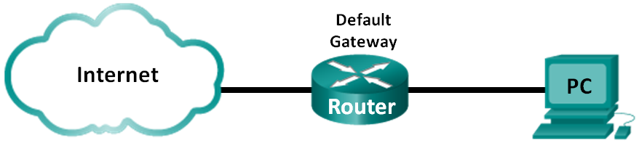

1. Objectives

Part 1: Identify the Different Types of IPv6 Addresses

Part 2: Examine a Host IPv6 Network Interface and Address

Part 3: Practice IPv6 Address Abbreviation

Background / Scenario

With the depletion of the Internet Protocol version 4 (IPv4) network address space and the adoption and transition to IPv6, networking professionals must understand how both IPv4 and IPv6 networks function. Many devices and applications already support IPv6. This includes extensive Cisco device Internetwork Operating System (IOS) support and workstation/server operating system support, such as that found in Windows and Linux.

This lab focuses on IPv6 addresses and the components of the address. In Part 1, you will identify the IPv6 address types, and in Part 2, you will view the IPv6 settings on a PC. In Part 3, you will practice IPv6 address abbreviation.

1. Required Resources

* 1 PC (Windows 7 or 8 with Internet access)

1. Identify the Different Types of IPv6 Addresses

In Part 1, you will review the characteristics of IPv6 addresses to identify the different types of IPv6 addresses.

* 1. Review the different types of IPv6 addresses.

An IPv6 address is 128 bits long. It is most often presented as 32 hexadecimal characters. Each hexadecimal character is the equivalent of 4 bits (4 x 32 = 128). A non-abbreviated IPv6 host address is shown here:

**2001:0DB8:0001:0000:0000:0000:0000:0001**

A hextet is the hexadecimal, IPv6 version of an IPv4 octet. An IPv4 address is 4 octets long, separated by dots. An IPv6 address is 8 hextets long, separated by colons.

An IPv4 address is 4 octets and is commonly written or displayed in decimal notation.

**255.255.255.255**

An IPv6 address is 8 hextets and is commonly written or displayed in hexadecimal notation.

**FFFF:FFFF:FFFF:FFFF:FFFF:FFFF:FFFF:FFFF**

In an IPv4 address, each individual octet is 8 binary digits (bits). Four octets equals one 32-bit IPv4 address.

**11111111 = 255**

**11111111.11111111.11111111.11111111 = 255.255.255.255**

In an IPv6 address, each individual hextet is 16 bits long. Eight hextets equals one 128-bit IPv6 address.

**1111111111111111 = FFFF**

**1111111111111111.1111111111111111.1111111111111111.1111111111111111. 1111111111111111.1111111111111111.1111111111111111.1111111111111111 = FFFF:FFFF:FFFF:FFFF:FFFF:FFFF:FFFF:FFFF**

If we read an IPv6 address starting from the left, the first (or far left) hextet identifies the IPv6 address type. For example, if the IPv6 address has all zeros in the far left hextet, then the address is possibly a loopback address.

**0000**:0000:0000:0000:0000:0000:0000:0001 = loopback address

::1 = loopback address abbreviated

As another example, if the IPv6 address has FE80 in the first hextet, then the address is a link-local address.

**FE80**:0000:0000:0000:C5B7:CB51:3C00:D6CE = link-local address

**FE80**::C5B7:CB51:3C00:D6CE = link-local address abbreviated

Study the chart below to help you identify the different types of IPv6 address based on the numbers in the first hextet.

|  |  |
| --- | --- |
| First Hextet (Far Left) | Type of IPv6 Address |
| 0000 to 00FF | Loopback address, any address, unspecified address, or IPv4-compatible |
| 2000 to 3FFF | Global unicast address (a routable address in a range of addresses that is currently being handed out by the Internet Assigned Numbers Authority [IANA]) |
| FE80 to FEBF | Link-local (a unicast address which identifies the host computer on the local network) |
| FC00 to FCFF | Unique-local (a unicast address which can be assigned to a host to identify it as being part of a specific subnet on the local network) |
| FF00 to FFFF | Multicast address |

There are other IPv6 address types that are either not yet widely implemented, or have already become deprecated, and are no longer supported. For instance, an **anycast address** is new to IPv6 and can be used by routers to facilitate load sharing and provide alternate path flexibility if a router becomes unavailable. Only routers should respond to an anycast address. Alternatively, **site-local addresses** have been deprecated and replaced by unique-local addresses. Site-local addresses were identified by the numbers FEC0 in the initial hextet.

In IPv6 networks, there are no network (wire) addresses or broadcast addresses as there are in IPv4 networks.

* 1. Match the IPv6 address to its type.

Match the IPv6 addresses to their corresponding address type. Notice that the addresses have been compressed to their abbreviated notation and that the slash network prefix number is not shown. Some answer choices must be used more than once.

|  |  |  |  |
| --- | --- | --- | --- |
| IPv6 Address | Answer |  | Answer Choices |
| 2001:0DB8:1:ACAD::FE55:6789:B210 | 1. _b___ |  | a. Loopback address |
| ::1 | 2. _a___ |  | b. Global unicast address |
| FC00:22:A:2::CD4:23E4:76FA | 3. _d___ |  | c. Link-local address |
| 2033:DB8:1:1:22:A33D:259A:21FE | 4. _b___ |  | d. Unique-local address |
| FE80::3201:CC01:65B1 | 5. _c___ |  | e. Multicast address |
| FF00:: | 6. _e___ |  |  |
| FF00::DB7:4322:A231:67C | 7. _e___ |  |  |
| FF02::2 | 8. _e___ |  |  |

1. Examine a Host IPv6 Network Interface and Address

In Part 2, you will check the IPv6 network settings of your PC to identify your network interface IPv6 address.

* 1. Check your PC IPv6 network address settings.
     1. Verify that the IPv6 protocol is installed and active on your PC-A (check your Local Area Connection settings).
     2. Click the Windows **Start** button and then **Control Panel** and change **View by: Category** to **View by: Small icons**.
     3. Click the **Network and Sharing Center** icon.
     4. On the left side of the window, click **Change adapter settings**. You should now see icons representing your installed network adapters. Right-click your active network interface (it may be a **Local Area Connection** or a **Wireless Network Connection**), and then click **Properties**.
     5. You should now see your Network Connection Properties window. Scroll through the list of items to determine whether IPv6 is present, which indicates that it is installed, and if it is also check marked, which indicates that it is active.

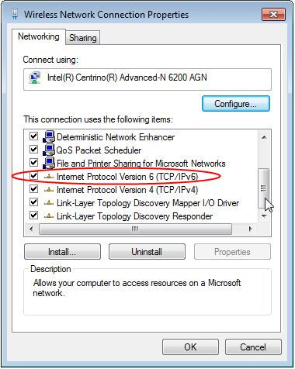

* + 1. Select the item **Internet Protocol Version 6 (TCP/IPv6)** and click **Properties**. You should see the IPv6 settings for your network interface. Your IPv6 properties window is likely set to **Obtain an IPv6 address automatically**. This does not mean that IPv6 relies on the Dynamic Host Configuration Protocol (DHCP). Instead of using DHCP, IPv6 looks to the local router for IPv6 network information and then auto-configures its own IPv6 addresses. To manually configure IPv6, you must provide the IPv6 address, the subnet prefix length, and the default gateway.

**Note**: The local router can refer host requests for IPv6 information, especially Domain Name System (DNS) information, to a DHCPv6 server on the network.

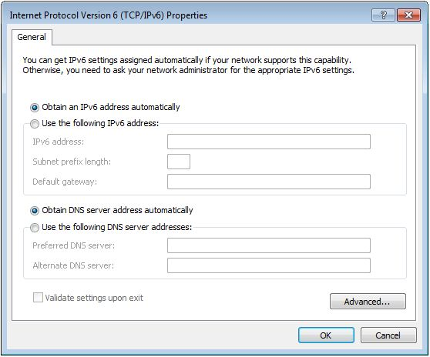

* + 1. After you have verified that IPv6 is installed and active on your PC, you should check your IPv6 address information. To do this, click the **Start** button, type **cmd** in the *Search programs and files* form box, and press Enter. This opens a Windows command prompt window.
    2. Type **ipconfig /all** and press Enter. Your output should look similar to this:

C:\Users\user> **ipconfig /all**

Windows IP Configuration

<output omitted>

Wireless LAN adapter Wireless Network Connection:

Connection-specific DNS Suffix . :

Description . . . . . . . . . . . : Intel(R) Centrino(R) Advanced-N 6200 AGN

Physical Address. . . . . . . . . : 02-37-10-41-FB-48

DHCP Enabled. . . . . . . . . . . : Yes

Autoconfiguration Enabled . . . . : Yes

**Link-local IPv6 Address . . . . . : fe80::8d4f:4f4d:3237:95e2%14(Preferred)**

IPv4 Address. . . . . . . . . . . : 192.168.2.106(Preferred)

Subnet Mask . . . . . . . . . . . : 255.255.255.0

Lease Obtained. . . . . . . . . . : Sunday, January 06, 2013 9:47:36 AM

Lease Expires . . . . . . . . . . : Monday, January 07, 2013 9:47:38 AM

Default Gateway . . . . . . . . . : 192.168.2.1

DHCP Server . . . . . . . . . . . : 192.168.2.1

DHCPv6 IAID . . . . . . . . . . . : 335554320

DHCPv6 Client DUID. . . . . . . . : 00-01-00-01-14-57-84-B1-1C-C1-DE-91-C3-5D

DNS Servers . . . . . . . . . . . : 192.168.1.1

8.8.4.4

<output omitted>

* + 1. You can see from the output that the client PC has an IPv6 link-local address with a randomly generated interface ID. What does it indicate about the network regarding IPv6 global unicast address, IPv6 unique-local address, or IPv6 gateway address?

Because there is only a link-local address and not a global unicast IPv6 address, this probably means IPv6 is not installed/configured on the gateway router, and therefore cannot give the client PC IPv6 information such as the subnet mask or global unicast address.

____________________________________________________________________________________

____________________________________________________________________________________

* + 1. What kind of IPv6 addresses did you find when using **ipconfig /all**?

Just the link-local IPv6 address.

____________________________________________________________________________________

____________________________________________________________________________________

1. Practice IPv6 Address Abbreviation

In Part 3, you will study and review rules for IPv6 address abbreviation to correctly compress and decompress IPv6 addresses.

* 1. Study and review the rules for IPv6 address abbreviation.

**Rule 1**: In an IPv6 address, a string of four zeros (0s) in a hextet can be abbreviated as a single zero.

2001:0404:0001:1000:**0000:0000**:0EF0:BC00

2001:0404:0001:1000:**0**:**0**:0EF0:BC00 (abbreviated with single zeros)

**Rule 2**: In an IPv6 address, the leading zeros in each hextet can be omitted, trailing zeros cannot be omitted.

2001:**0**404:**000**1:1000:0000:0000:**0**EF0:BC00

2001:404:1:1000:0:0:EF0:BC00 (abbreviated with leading zeros omitted)

**Rule 3**: In an IPv6 address, a single continuous string of four or more zeros can be abbreviated as a double colon (::). The double colon abbreviation can only be used one time in an IP address.

2001:0404:0001:1000**:0000:0000:**0EF0:BC00

2001:404:1:1000**::**EF0:BC00 (abbreviated with leading zeroes omitted and continuous zeros replaced with a double colon)

The image below illustrates these rules of IPv6 address abbreviation:

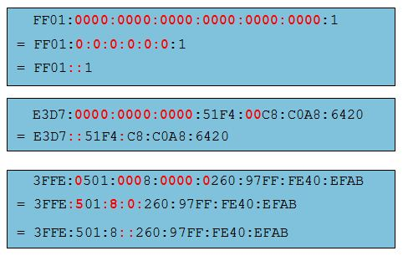

* 1. Practice compressing and decompressing IPv6 addresses.

Using the rules of IPv6 address abbreviation, either compress or decompress the following addresses:

* + - 1. 2002:0EC0:0200:0001:0000:04EB:44CE:08A2

2002:EC0:200:1::4EB:44CE:8A2

________________________________________________________________________________

* + - 1. FE80:0000:0000:0001:0000:60BB:008E:7402

FE80::1:0:60BB:8E:7402

________________________________________________________________________________

* + - 1. FE80::7042:B3D7:3DEC:84B8

FE80:0000:0000:0000:7042:B3D7:3DEC:84B8

________________________________________________________________________________

* + - 1. FF00::

FF00:0000:0000:0000:0000:0000:0000:0000

________________________________________________________________________________

* + - 1. 2001:0030:0001:ACAD:0000:330E:10C2:32BF

2001:30:1:ACAD::330E:10C2:32BF

________________________________________________________________________________

1. Reflection
   1. How do you think you must support IPv6 in the future?

All future devices made should support IPv6, and any new networks or network devices should be configured to use IPv6 in order to facilitate a better/faster/more secure network and to help with the adoption to IPv6. New technologies or protocols may be needed to better handle and use IPv6 as time goes on.

_______________________________________________________________________________________

_______________________________________________________________________________________

* 1. Do you think IPv4 networks continue on, or will everyone eventually switch over to IPv6? How long do you think it will take?

Eventually everyone will either switch over to IPv6 or decommission their network, but that will take a very long time. Many businesses/environments will continue using whatever they have until they have no choice but to change. As long as our technology still supports IPv4, there will be people and businesses not using IPv6. I could see this taking another 30 to 50 years before IPv4 is fully gone.

_______________________________________________________________________________________

_______________________________________________________________________________________